Cultural Souls reflected in their Mathematics:
the Spenglerian Interpretation
D.L. McNaughton
Centro de Educación Permanente "Blas Infante", Albox, Spain
Received: 31/05/2015  Accepted: 04/08/2015 | Corresponding author: David L. McNaughton (DLMcN@yahoo.com)
ABSTRACT
This article examines Oswald Spengler's claim that similarities may be discerned in the style of mathematics, art and music developed by a particular High Culture – looking first at his discussions of the Ancient Greeks and how their thought-processes differed from that of Western Europeans, as well as from the Persians and Arabs. An attempt is then made to extend Spengler's theory to the Ancient Egyptians (referring to their Rhind Papyrus) and to the Sino-Japanese (by appealing to their 'Sangaku' mathematical art-forms). Finally, it is suggested that we may already be able to identify certain distinctive features and characteristics of the recently born Russian Culture.

KEYWORDS: Spengler, Comparative Mathematics, Ancient Greece, Calculus, Ancient Egypt, Rhind Papyrus, Sangaku, Russia

INTRODUCTION

Immediately after the First World War, a German philosopher-historian published a two-volumed book which evoked great interest and discussion (Spengler, 1918 and 1922). After the 1940s, however, its popularity faded, probably because it shared some common ground with Nazi ideals – although Spengler (1933) criticized and was then disowned by them (Felken, 1988; Farrenkopf, 2001; McNaughton, 2012).

Nevertheless, politics is not really the dominant theme in "The Decline of the West". Spengler's principal thesis is that a culture or civilization possesses its own distinctive soul, such that similar patterns may be discerned in its 'creative expressions' in art, architecture, science, mathematics and religion. For example, he argues that soaring Gothic cathedrals and the characteristic style of Western music and painting, and the mathematical tools which it developed, are all related to that culture's urge to explore across distant horizons, as well as to its intense interest in the past and concern for the far future (Spengler, 1918, pp. 174-178, 203, 183-184, 65). In a contrasting manner, the Ancient Greeks focussed primarily on the corporeal and the 'here-now', such that sculpture was their favoured art-form.

MATHEMATICS IN THE CLASSICAL (GRAECO-ROMAN) WORLD

For Greek mathematicians, number was "the essence of all things perceptible to the senses" (Spengler, 1918, pp. 63-64) – usually involving the "measurement of something near and corporeal". In order to ensure that these measurements were well defined, they had to be represented by rational quantities (i.e., which may be written as the quotient of two whole numbers). However, when the Greeks tried to calculate the length of a diagonal in a square or rectangle, they often encountered values like the square root of 2 – which can never be expressed in terms of integers. Numbers like that are termed irrational, and their discovery was regarded as "a secret too dangerous to be revealed", such that a legend grew up claiming that the man who had dared to publish this hidden mystery had perished by shipwreck (Spengler, 1918, p. 65).

What might be called their 'mental block' (which insisted that they should work only with real, tangible values) helps to explain why there was no zero in the Roman numeral-system; negative quantities were similarly eschewed (Spengler, 1918, p. 66).

Archimedes was extremely proud of his demonstration that the volume of a sphere is 4π/3 times the radius cubed, and asked for this formula to be inscribed on his tombstone. According to one source, his proof involved cutting the sphere up into thinner and thinner slices, and then computing the volumes of the cylinders which would fit, as closely as possible, inside and outside each slice. Another approach compared the respective masses of a sphere, a cone and a cylinder.

Using integral calculus, on the other hand, the formula for the volume of a sphere is derived in just a few lines.

WESTERN CULTURE

Differential and integral calculus emerged in Europe in the 17th century as a totally new mathematical tool – discovered and devised simultaneously by Newton and Leibniz. Its distinguishing feature lies in its ability to deal with continuous rates of change (Spengler, 1918, p. 126 note 3). This was a thought-process completely alien to Greek mathematicians – a limitation which led to Zeno formulating his so-called paradox of the race between Achilles and the tortoise.

Spengler (1918, pp. 230-231) insists that it was no accident that the High Culture which gave birth to calculus, also created a music where "Melody and embellishment join to produce the Motive, and this in development leads to the rebirth of counterpoint in the form of the fugal style, of which Frescobaldi was the first master and Bach the culmination".

West European mathematicians also conceived number-types which the Greeks never even dreamed of, such as the square root of minus one (often represented by 'i') – and the quantity written as 'e', termed "transcendental" because it cannot be the root of any polynomial equation.

Thus, the identity
e^{iπ} + 1 = 0
is widely considered to be one of the most beautiful 'jewels' in Western mathematics: nobody ever regarded its discovery as "the sacrilegious revelation of a forbidden secret".

THE ARAB-PERSIAN OUTLOOK COMPARED WITH OTHERS

Spengler (1918, p. 382) describes the Arab-Persian Culture as one which focussed on "the idea of substances with visible or secret attributes" – thereby developing the science of Alchemy). He also points out that the most striking features of Islamic architecture are found concealed inside the mosque (Spengler, 1918, pp. 184, 224).

He explains: "What we call Statics, Chemistry and Dynamics ... are really the respective physical systems of the [Classical Greek, Arab-Persian and Western] souls... Corresponding to these sciences, each to each, we have the mathematics of Euclidean Geometry, Algebra, and Higher Analysis..." (Spengler, 1918, p. 384). He also compares each Culture's approach to painting and art-work: "The Ancient Greeks ... recognised as actual only that which was immediately present in time and place – and thus it repudiated the background as pictorial element. The [Western one] strove through all sensuous barriers towards infinity – and it projected the centre of gravity of the pictorial idea into the distance by means of perspective. The [Persians and Arabs] felt all happening as an expression of mysterious powers that filled the world-cavern with their spiritual substance – and it shut off the depicted scene with a gold background, that is, by something that stood beyond and outside all nature-colours" (Spengler, 1918, pp. 247-248).

When discussing mathematics, Spengler (1918, pp. 71-73) emphasizes that the 'algebra' which was developed by Al-Khwarizmi and others, involved working with undefined magnitudes. Thus, their equations contained unknowns 'x' and 'y' whose values had not yet been evaluated.

ANCIENT EGYPTIANS

The Rhind Papyrus gives an insight into some of the problems addressed by ancient Egyptian mathematicians. In particular, they went to the trouble of expressing fractions 2/n in the form of a series. For example, they discovered that:
2/101 = 1/101 + 1/202 + 1/303 + 1/606.

The papyrus presents calculations of this sort for every such fraction between 2/3 and 2/101 – i.e., covering all odd values of n.

For us, identities like that above are just a curiosity; we would probably have remained unaware of them without the Rhind papyrus. But why did the Egyptians regard them as significant and important?

It seems that they needed those expressions for dividing larger quantities; e.g. the papyrus mentions that:
7/10 = 2/3 + 1/30, which then becomes 1/2 + 1/6 + 1/30 using the 2/n table. For us, of course, this is a somewhat strange and clumsy way of performing division.

Spengler (1918, pp. 188-189) depicts the Egyptian soul as one which "saw itself moving down a narrow and inexorably prescribed life-path" ... "The tomb temples of the Old Kingdom ... represent, not a purposed organization of space such as we find in the mosque and the cathedral, but a rhythmically ordered sequence of spaces ... that grow ever narrower and narrower".

JAPAN AND CHINA

"The [Chinese] temple is not a self-contained building, but a lay-out – in which hills, water, trees, flowers and stones in definite forms and dispositions are just as important as gates, walls, bridges and houses. This Culture is the only one in which the art of gardening is a grand religious art" (Spengler, 1918, p. 190). "The Chinese park avoids energetic perspective. It lays horizon behind horizon and, instead of pointing to a goal, tempts to wander. The Chinese 'cathedral' of the early time, the Pi-Yung, [is built around paths which wind] through gates and thickets, [and across] stairs and bridges and courts" (Spengler, 1922, p. 287). Here, it is illuminating to compare chess with the Sino-Japanese game of GO – where the pieces do not move around the board, but remain stationary after they have been placed down. Despite that, GO is at least as subtle and difficult to master as chess is.

Guided by the 'Tao' of life's path, the Chinese soul meanders through its world (Spengler, 1918, pp. 203, 190, 310 note 2). It is probably no coincidence that this High Culture discovered and developed the medical technique of acupuncture.

Much of Japan's cultural heritage was derived from China. Nevertheless, because of widespread destruction during the Mongol invasion, some aspects of Chinese Culture (such as Tang dynasty architecture) are better preserved in Japan. Earlier, many details of Chinese mathematical accomplishments were lost when Shi-Hwang-Di carried out his infamous 'burning of the books'.

But Japanese geometry has shown us some very original 'theorems' – which quite possibly would never have been discovered by Western mathematicians – for example:

No matter how one triangulates a cyclic polygon, the sum of the inradii of the triangles is constant; [Online: http://en.wikipedia.org/wiki/Japanese_theorem_for_cyclic_polygons ]

and:

Triangulating an arbitrary concyclic quadrilateral by its diagonals yields four overlapping triangles (each diagonal creates two triangles) – and the centres of the incircles of those triangles form a rectangle. [Online: http://en.wikipedia.org/wiki/Japanese_theorem_for_cyclic_quadrilaterals ]

In Japan, it is customary to place wooden tablets (known as Sangaku) as offerings at Shinto shrines or Buddhist temples after engraving geometrical problems on their surfaces. Many of these have been well illustrated and mathematically analysed by Fukagawa and Rothman (2008; Rothman, 1988). The three examples presented below, seem consistent with Spengler's description of Sino-Japanese architecture and garden design. (Fukagawa and Rothman supply answers to the first and third problems, but not to the second one).

It might be said that this manifestation of Japanese mathematics served as an art-form – in addition to expressing religious devotion.

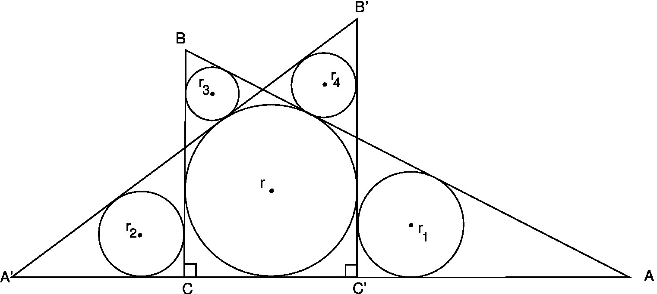

Problem 1. From Fukagawa and Rothman, p. 158, figure 5.17.
Two different-sized right-angled triangles are based on the same line. The inscribed circle with radius r is common to both triangles. Four other circles (with radii r₁, r₂, r₃ and r₄, all different) are inscribed as shown. Prove that r₁.r₃ is always equal to r₂.r₄.

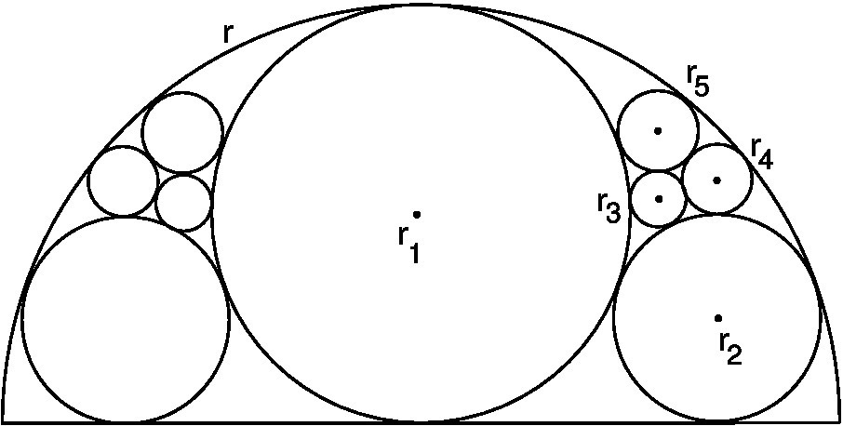

Problem 2. From Fukagawa and Rothman, p. 335, figure 10.23.
Nine circles fit inside a semicircle of radius r. The largest (i.e., central) circle has radius r₁. The diagram is symmetrical, so the four circles on the left have the same radii as those on the right, that is r₂, r₃, r₄ and r₅. Prove that r₂ = r/4; r₃ = r/15; r₄ = r/12; r₅ = r/10.

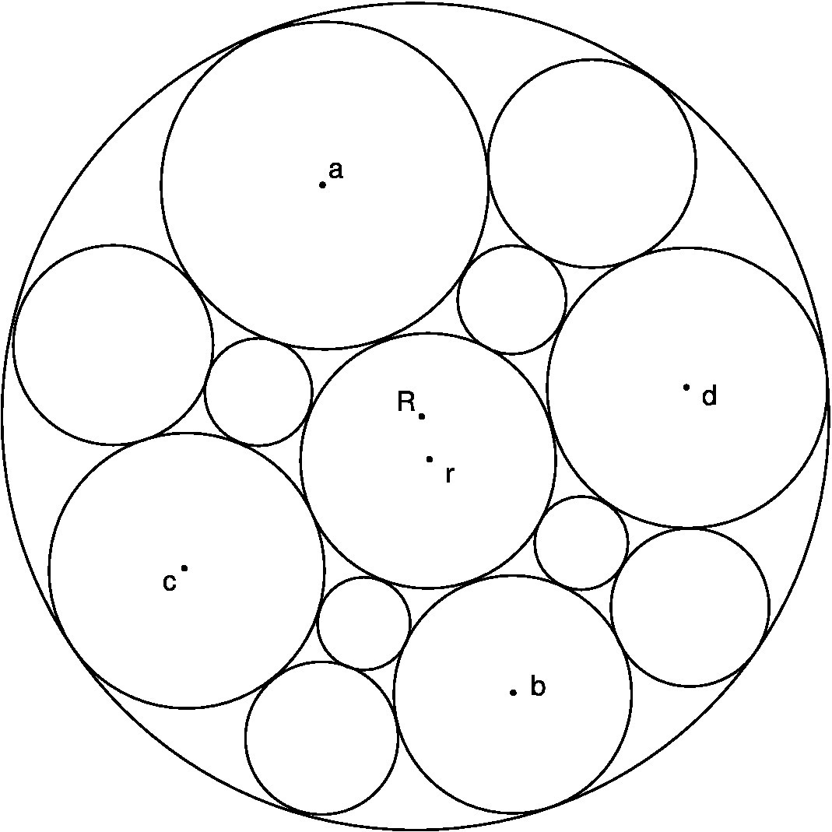

Problem 3. From Fukagawa and Rothman, p. 200, figure 6.11.
Thirteen circles, all of different sizes, fit exactly inside a larger one whose radius is R. Four of them have radii of length a, b, c and d, as shown. Prove that the following relation always holds:
1/a + 1/b = 1/c + 1/d

RUSSIA AND THE FUTURE

Spengler (1922, pp. 192-196, and 1934) believes that a new High Culture has recently crystallized in Russia. He even attempted to discern and analyse the nature and character of its 'soul'. For example, he maintained that the Russian death-impulse "is an expressing and expanding of self (Sichentäussern) till 'it' in the man becomes identical with the boundless plain itself... That 'All are responsible for all' ... is the metaphysical fundament of all Dostoyevski's creation. Mystical Russian love is the love of brothers under equal pressure all along the earth., ever along and along" (Spengler, 1922, p. 295 note 1).

Spengler may not be completely correct in asserting that the 'prime symbol' of the new Russian Culture is the infinite plain. If so, he can perhaps be forgiven – because he made that assessment one hundred years ago. But if he is right that another 'Cultural organism' has indeed been born, then new discoveries and developments in mathematics, art and music will blossom there. On that assumption, can we try and guess what sort of mathematics might emerge?

Without doubt, Russian mathematicians have already made prominent contributions in that field. In particular, Grigori Perelman should be highlighted for demonstrating the truth of the Poincaré Conjecture. In 2006, the world-renowned journal “Science” recognized his achievement as the scientific ‘Breakthrough of the Year’ – the first time such a tribute had ever been accorded in mathematics (Mackenzie, 2006). For his work, Perelman was also awarded the highly prestigious Fields Medal – but refused it. After interviewing him, John Ball (outgoing president of the International Mathematical Union) remarked: "He has a different psychological make-up, which causes him to see life differently" (BBC News, 2006).

Earlier, Perelman had confirmed the Soul Conjecture with (what Wikipedia describes as) "an astonishingly concise proof". His two discoveries are important insights and landmarks in the development of mathematical topology (which may be defined as the study of spaces and their connectivity). So perhaps the new Russian mathematics will specialise in this topic? For example, eventually it might produce a comparatively simple proof of the Four Colour Theorem (explained by Appel and Haken, 1977).

If the Spenglerian 'timetable' is correct, Russian art, music and mathematics will attain their zenith (after a few more centuries) during what he calls their 'summertime' – so it is probably too soon to know how exactly they will manifest themselves. Despite that, it is worth asking whether the Russian ability and love for the [Western] game of Chess is evidence that a new cultural soul is unfolding in that landscape. Each piece on the chessboard commands or controls only certain squares, i.e. a 'subspace' of the whole. And game-strategy assesses how the power or potential of each piece can best coordinate and interact with the others.

In a different field, there might be grounds for arguing that it was no coincidence that the Periodic Table of the Elements was first conceived in a Russian mind – that of Dmitri Mendeleyev – rather than a Western one.

ACKNOWLEDGEMENT

Tony Rothman very kindly supplied the diagrams for Problems 1, 2 and 3.

REFERENCES

APPEL, K. and HAKEN, W. (October 1977). Solution of the Four Color Map Problem. Scientific American, Vol. 237, No. 4, 108–121.

BBC NEWS, SCIENCE/NATURE (22 August 2006). Maths genius declines top prize.
Online: http://news.bbc.co.uk/2/hi/science/nature/5274040.stm

FARRENKOPF, J. (2001). Prophet of Decline: Spengler on World History and Politics, p. 236. Baton Rouge: Louisiana State University Press.

FELKEN, D. (1988). Oswald Spengler: Konservativer Denker zwischen Kaiserreich und Diktatur, pp. 194-198 and 217-223. Munich: C.H. Beck.

FUKAGAWA, H. and ROTHMAN, T. (2008). Sacred Mathematics – Japanese Temple Geometry. Oxford: Princeton University Press. Accessible: kknop.com/math/sangaku.pdf

MacKENZIE, D. (December 2006). Breakthrough of the year: The Poincaré Conjecture—proved. Science, Vol. 314, No. 5807, 1848–1849. Online: http://www.sciencemag.org/content/314/5807/1848.full

McNAUGHTON, D.L. (2012). Spengler's philosophy, and its implication that Europe has 'lost its way'. Comparative Civilizations Review, Vol. 67, 7-15. Online: http://www.dlmcn.com/oswaldspengler.html

ROTHMAN, T. (May 1998). Japanese Temple Geometry. Scientific American, Vol. 278, No. 5, 84-91.

SPENGLER, O. (1918). The Decline of the West, Vol. I. London: George Allen & Unwin. (Original German title: Der Untergang des Abendlandes). Online: https://archive.org/stream/Decline-Of-The-West-Oswald-Spengler/Decline_Of_The_West

SPENGLER, O. (1922). The Decline of the West, Vol. II. London: George Allen & Unwin. Online: https://archive.org/stream/Decline-Of-The-West-Oswald-Spengler/Decline_Of_The_West#page/n661/mode/2up

SPENGLER, O. (1933). The Hour of Decision, pp. xiv et seq., xii, 7. New York: Alfred A. Knopf. (Original German title: Jahre der Entscheidung).

SPENGLER, O. (1934). Politische Schriften, pp. 122, 136-137. Munich: C.H. Beck.

= = = = = = = = = = = = = = = = = = = = = = = = = = = = = = = = = = = = = = = = = = = = = = = = = = = = = = = = =

Author’s website:
http://DLMcN.com

E-mail: DLMcN@yahoo.com

Correspondence on Spengler:
http://DLMcN.com/histcorr.html

Mathematics page:
http://DLMcN.com/page5.html

